

**YEAR 5**

**WORK PACK:**

**SUMMER BONANZA!**

**Creative Tasks**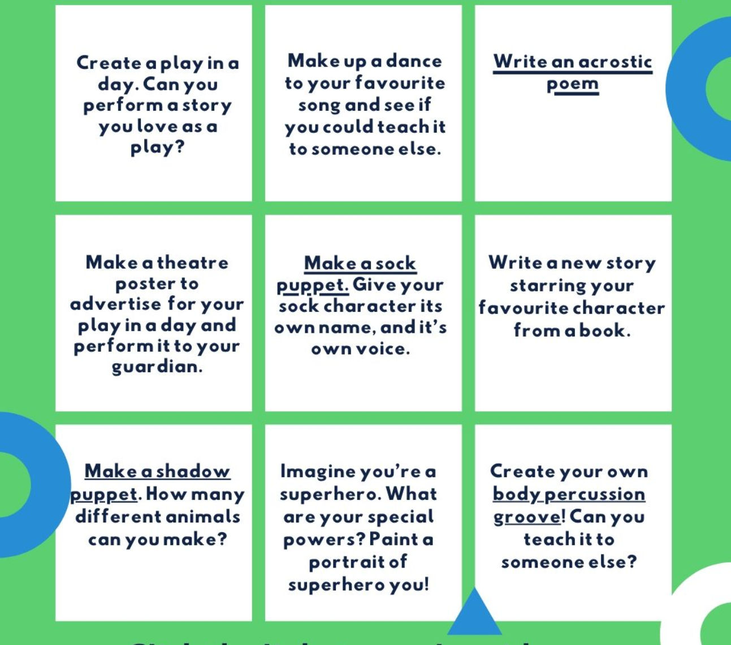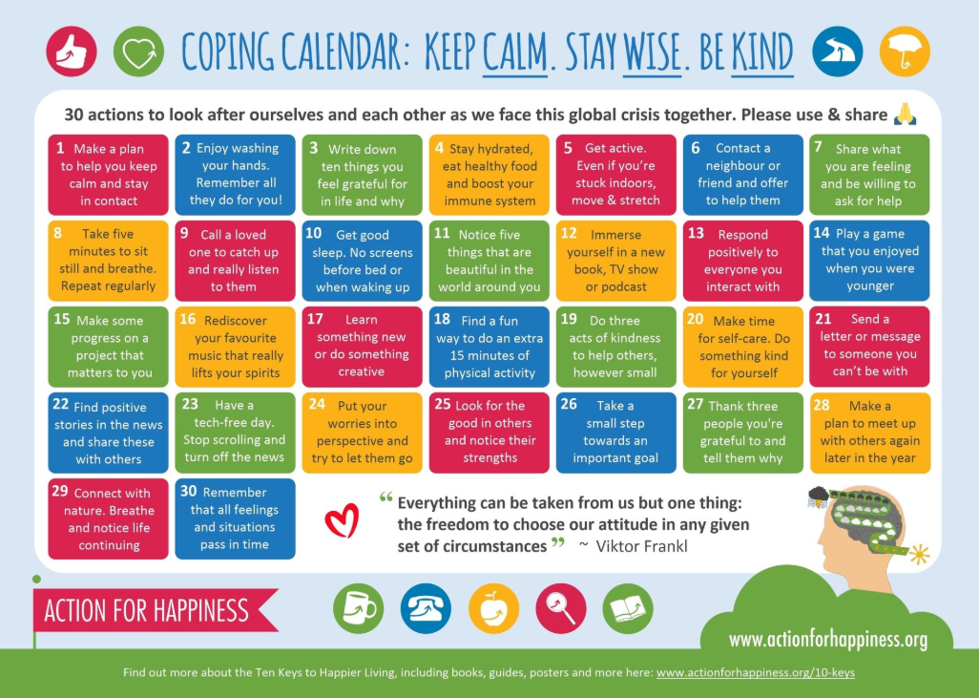

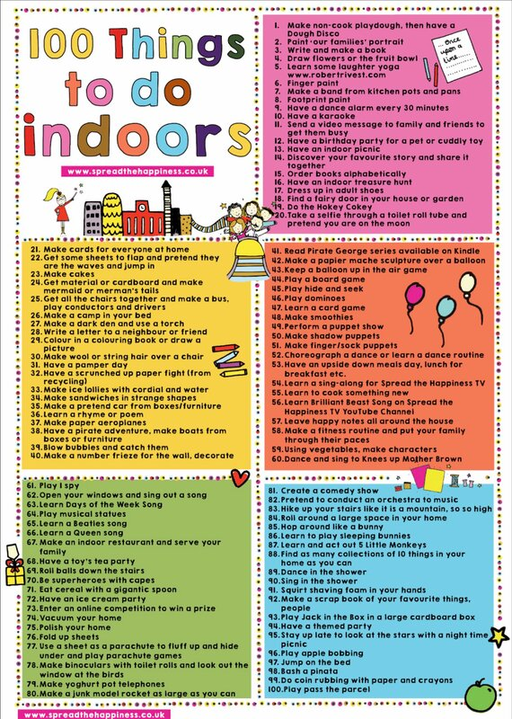

**Reading**

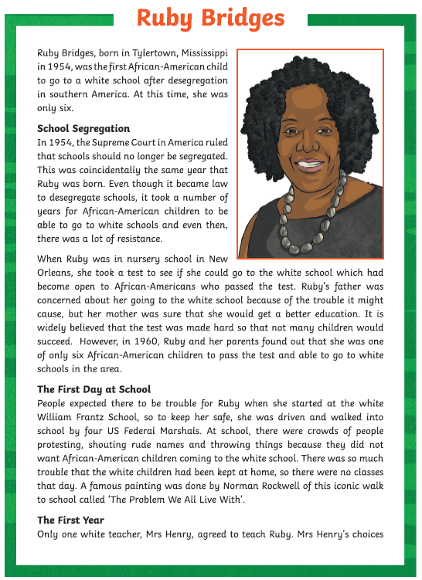 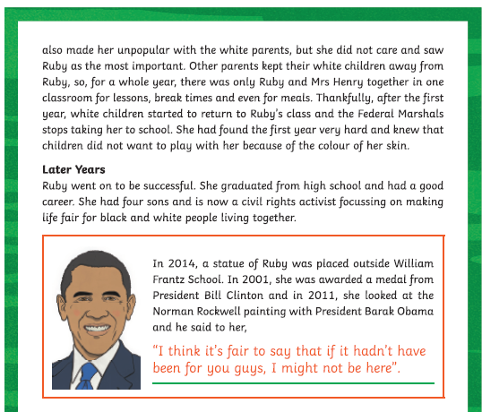

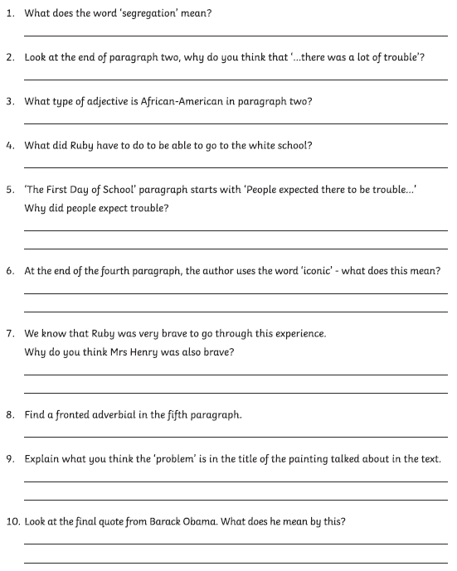

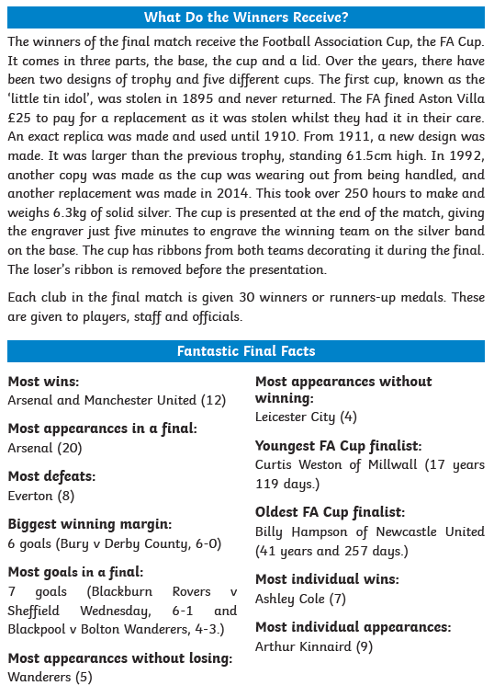

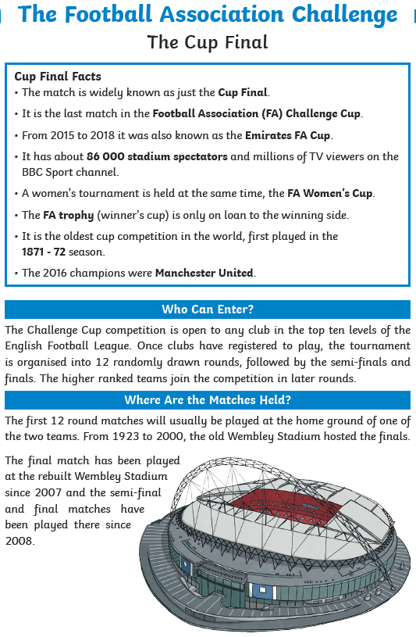

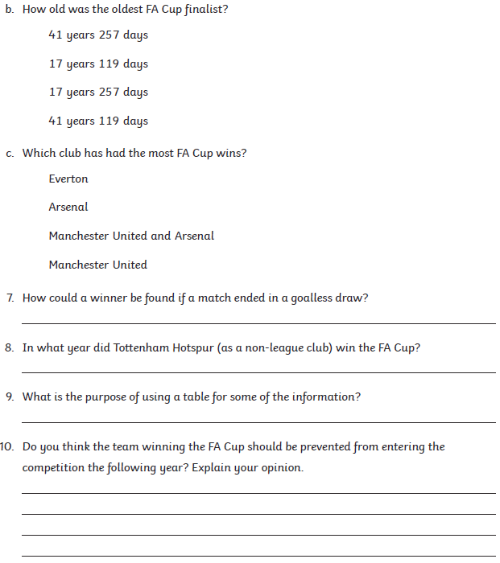

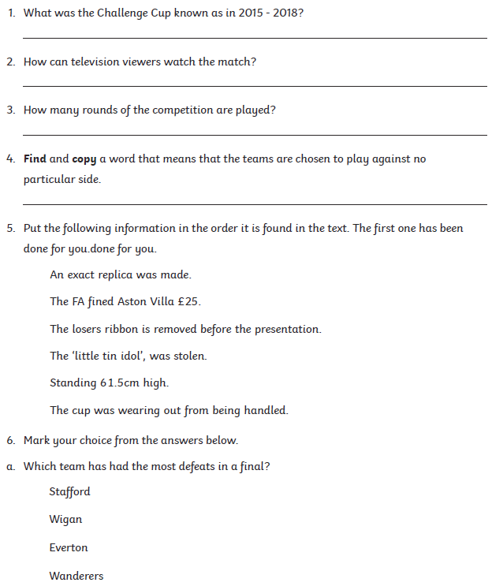

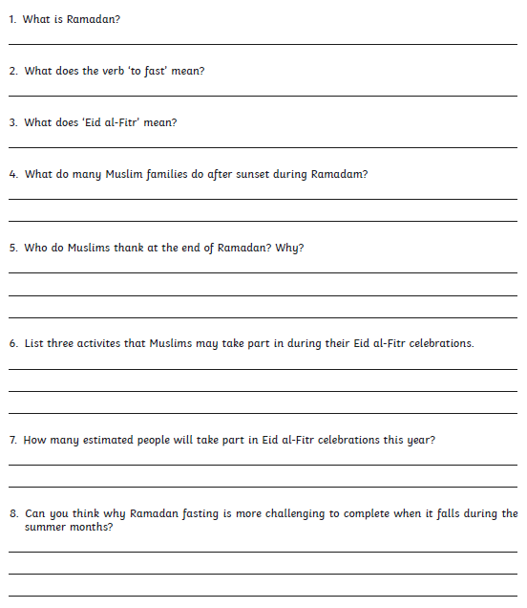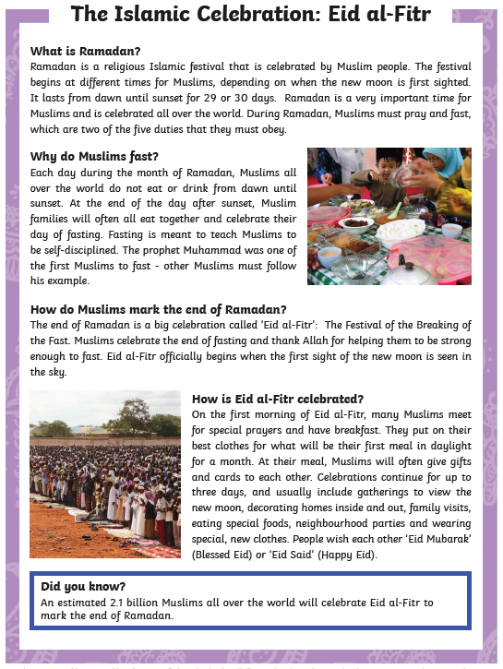

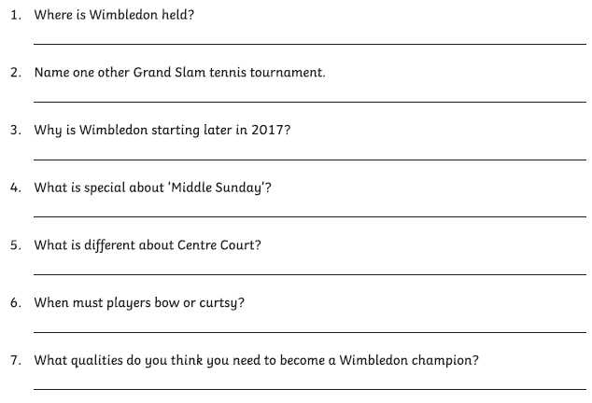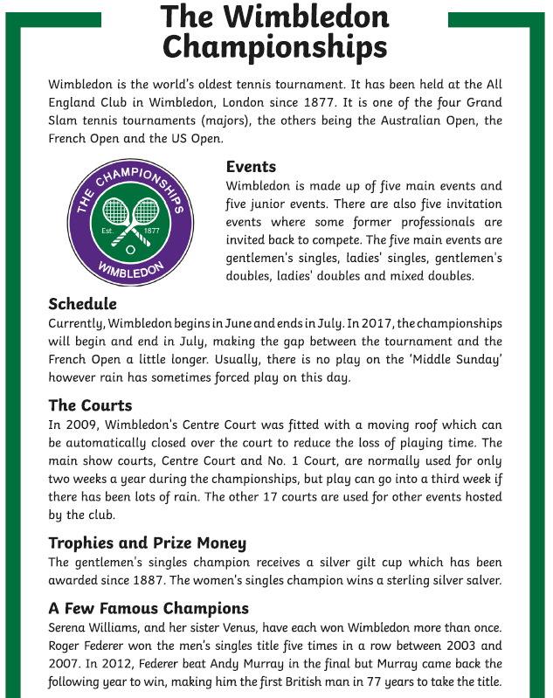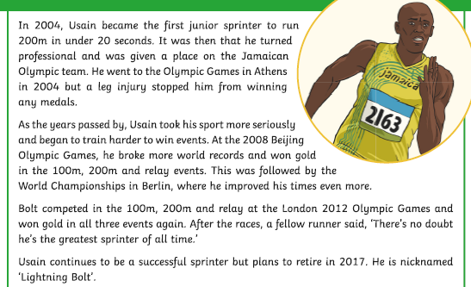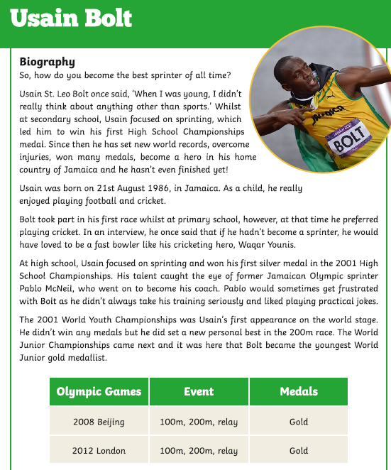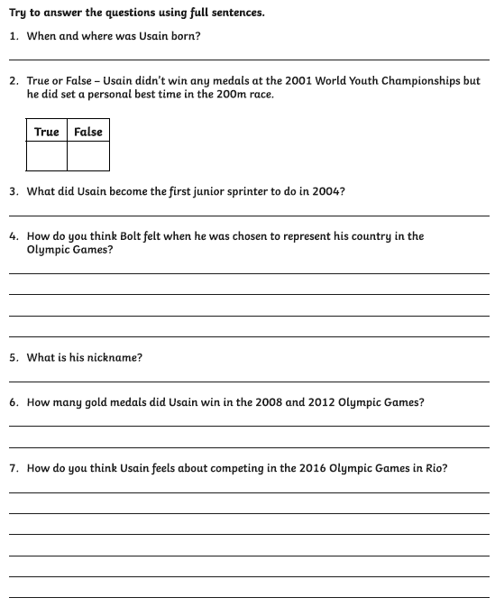

|  |  |  |  |  |  |
| --- | --- | --- | --- | --- | --- |
|  |  |  |  |  |  |

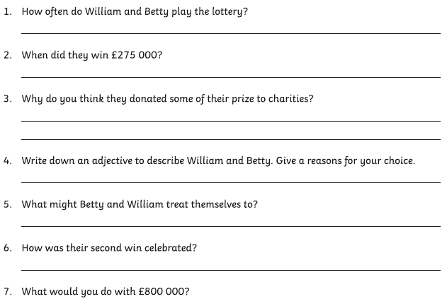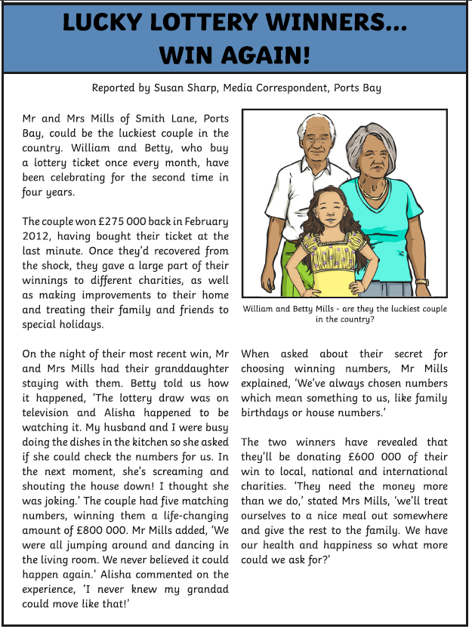**Writing**

**Writing**

|  |  |
| --- | --- |
|  |  |
| Welcome to Cat School. What is it like? What do you learn there? Write a narrative as one of the pupils, students or Headteacher! | You wake up in the morning to find an octopus in the sink. How did it get there? What does it want? How do you help it or persuade it to leave? Write a comedy story about his visit. |
|  |  |
| Who is this oracle, and what does she tell you? Do you go on a quest to find something to solve a problem? Does she give you magical powers? Write an adventure story around this theme. | Grandma’s house is moving! Why is it moving, and where will it go? Are you in the house with her, or is she trying to reach you? Write a dramatic story. |
|  |  |
| Where is this football pitch, and why is it up there? You are the captain of the team that must score into the goal at the top of the slope. How do you turn the disadvantage around? Write a story to describe the game of your life! | You fall down the man-hole and into the sewers. Tired and desperate to find your way out, you read a dead end and meet “The Thing”. Is it a friend or a foe? Write a story to describe what happens next. |
|  |  |
| Study this picture closely – what do you see? Whose house could this be, and why do they need the tiger as a guard? Write a quest story where the final stop is a visit to this house. | What would you do if you had a pet dragon? What would you name them, and where would you go? Write an adventure story about the fun and mischief you would get up to! |
|  |  |
| Who is this space warrior and her dog? Which planet have they landed on, and are they heroes or villains? Decide which side they are on, then write a job advert for more recruits! | One of these people is you. What are you and your companion up to, why are you in the tree? Are you observing something, or someone? Write a diary entry to describe what happened. |
|  |  |
| Who is this happy vampire? Write and illustrate a comic about them and their little pet bat. Will it be an adventure, a quest, a horror story or a comedy? The possibilities are endless. | Turns out the Minotaur is very much alive and living in modern Britain! What damage will it cause? Where does it live? Design a news report about the discovery of the Minotaur, and what happens when it goes on a rampage in London. |

Here are more interesting pictures. Make up your own ideas for writing and have a go!

|  |  |
| --- | --- |
|  |  |
|  |  |
|  |  |
|  |  |

**Maths**



