Year 4 Homework Matrix
Well Being | Cooking | Science
Draw a tree of life  - To share your story from their perspective  - To think about where you come from  - To think about what you are good at  - To think about your hopes, dreams, and wishes  - To think about the significant people in your lives  Step 1:  Draw a magnificent tree. Think about what kind of tree it is.  If you need help drawing your tree, watch this drawing video:  https://youtu.be/ID5H9VVyz4U  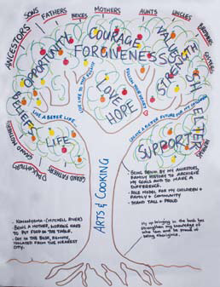  Step 2:  Then create the tree of your life:  Each part of the tree represents a part of your life.  The ROOTS of the tree:  • Where do you come from?  This can include places you come from, the people, the ideas, traditions, etc. This can include things such as books, religion, language, ancestry, and social movements.  • Who are the people who have taught you the most in life?  • What is your favourite place at home, a treasured song, dance or item (such as a teddy bear, blanket, or picture)?  Draw the GROUND:  • Where do you currently live?  • What activities do you do in your everyday life?  Draw the TRUNK:  • What do you value?  • What skills and abilities do you have?  • What qualities and characteristics do you have?  • What are you committed to and what is your purpose(s)?  Draw the BRANCHES:  • What are your hopes, dreams and wishes?  These could be for you or others  • Where would you like your life to be heading?  Draw the LEAVES:  • Who is important to you?  These people could be alive or deceased.  These people can be children or adults.  This can include people who you haven’t met but contributed to your life in important ways (an author, artist, musician, or historical figure).  Draw the FRUIT:  • What “gifts” have you received or what legacies have been passed on to you?  This includes being cared for, being loved, or having acts of kindness done for you.  Draw the SEEDS:  • What are the legacies or gifts you want to give others?  This could be specific, such as, “I want to give the gift of love to my children.”  This could be general, such as, “I want to be remembered as one who offered kindness to those who needed it.”  Draw a COMPOST HEAP:  • Who has been harmful or unkind in some way but should still be remembered?  • It may be possible that people in the compost heap are included in other parts of the tree | Banana split sundaes  Serves 8  ** If the recipe requires a hob or the oven, make sure you have an adult help you **  INGREDIENTS:  4 bananas  8 Lollipop sticks  160g chocolate chips  1 tbsp. coconut oil  60g rainbow sprinkles  8 cherries Whipped cream for serving  METHOD:  1. Line a large baking tray with parchment paper and set aside.  2. Cut the ends off of each banana to level the sides, then cut in half. Insert a popsicle stick into each banana piece and place on prepared baking sheet. Freeze for 2 hours.  3. In a medium microwave-safe bowl, combine chocolate chips and coconut oil and microwave in 30-second intervals, stirring in between, until completely melted. Pour sprinkles into another small bowl.  4. Dip the top of each frozen banana in chocolate, then roll the melted chocolate tip around in sprinkles. Return to baking sheet and freeze until the chocolate is firm, about 15 minutes.  5. Top each pop with whipped cream and garnish with a maraschino cherry. | Time Capsule  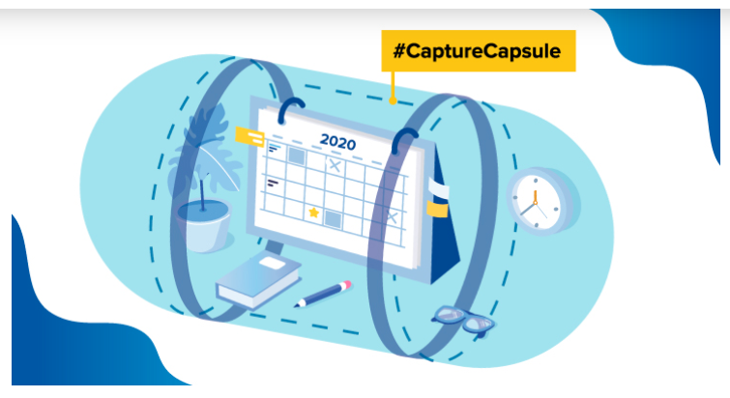  How to Build a COVID-19 Time Capsule  Assemble items that illustrate the experiences they are having and the changes in society that are taking place. Find a sturdy box or plastic bin where you and your family can deposit items they collect for the time capsule.  The box or bin should be good quality—able to withstand time—and have a secure lid. Keep the bin accessible at all times so items may be added often, but in a safe place where the memories can be secure. Encourage family members to decorate it, and put “DO NOT OPEN UNTIL 2030!” signs on the top. Consider creating a digital file where family photos and historical moments can be preserved and downloaded. Add a flash drive or printed items to the bin before sealing.  Plan now for a long-term place to store your bin when completed so it will be accessible in 10 years for a family journey back in time. If you like, you may register your #CaptureCapsule with the International Time Capsule Registry so you know where to find it and when it should be opened.  Suggestions of items to add to your bin include a weekly paragraph or journal entry from each family member, recording impressions and events of the quarantine life as your family stayed at home. Include photos of the family with a list of all names and ages both in the home and those who live away (grandparents, aunts, and uncles). Share how you stay in touch with your extended family.  Don’t forget to add copies of completed schoolwork. Capture how you celebrate birthdays, and major life events. Remember to add personal daily things like listing the games you play, the programs you watch, and the foods you prepare and eat together. Note those signs at the grocery store and other community changes.  New jokes, memes, and humour in any form would be excellent additions. Adding an empty roll of toilet paper with an explanation may say a lot in ten years! Photos of the family in masks or gloves would show the measures taken. Don’t forget the new phrases—with explanations—now commonly used such as “six-feet apart,” “social distancing,” “flattening the curve,” etc. Sudden changes catch our attention, but as they become the new normal, we are less likely to recall how life-changing they seemed. Daily recording is essential to keep up.  It is OK to include serious things like, how has COVID-19 touched your family’s health concerns; what measure are you taking to stay safe.  Record things you are thankful for, the music you listen to, the books you are reading, the spring time, the songs of the birds, or blossoming flowers. Feel free to add the things you would change if you could. You might capture what the family did for haircuts and what your daily routine is.  Writing down or video journaling your thoughts, dreams, and your biggest concerns will provide a window of understanding and reflection that will bring the memories of this time to life.  Your family is making history. Use your #CaptureCapsule to learn from the experience and see how you did in the rear-view mirror of 2030.
 | Geography
Animal observation:

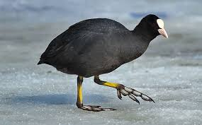

This is a coot, you may have seen them in the park.

They have a white patch on their heads. Why is this? Investigate the life of a coot by observing them in your local park and/or by researching them on the internet.

Here is a video to get you started:
https://www.youtube.com/watch?v=3DhdYalB_Gw

 | Reading
Scary Story
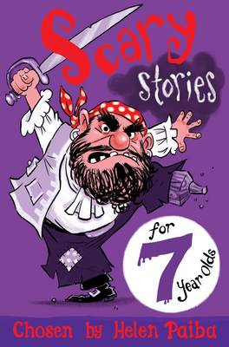

Curl up in bed alone, or with a family member and read an extract from: Scary Stories for 7 Year Olds.
Scary_Stories_for_7_Year_Olds_FINAL_opening_extract.pdf

 | DT
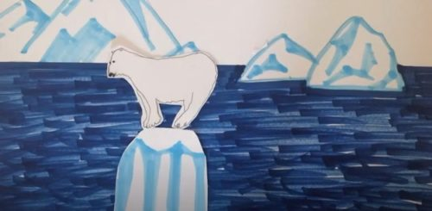
Stop Motion Animation

Click here for the instructions:
https://www.brecknock.camden.sch.uk/wp-content/uploads/2020/05/Eastside-Creativity-Challenge-Animation.pdf

Click here to watch the video:
https://www.youtube.com/watch?v=FEWlYxRuB_I&feature=youtu.be

