Research and write about your favourite sports team.  Remember to include different subheadings that will be relevant to your team. | 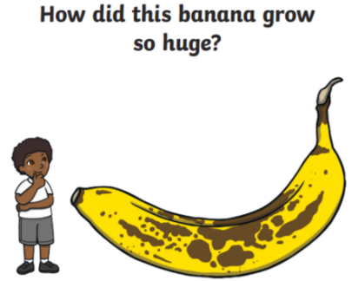  Write a story to explain how the banana got so big! Think about how the character / you would feel and include this in your writing. | Write a story about becoming a superhero for a day.  Think about what your powers would be, what would you do? Where would you go? What will happen? | Write an alternative ending to a traditional tale.  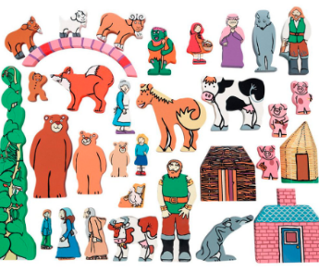  Here are some traditional tales you might remember, 3 Billy Goats Gruff, Little Red Riding Hood, The Gingerbread Man, Goldilocks and the 3 bears, The 3 little pigs | Invent a new animal.  Draw and describe what it looks like, what it sounds like, how it moves, and what it eats. Is it scary or cuddly or something else altogether? Would it be a pet or live in the wild?  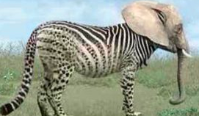
Year 1 Common Exception Words  This contains a number of games and activities that you can do around common exception words. Choose a range of different games and activities to do or work through the booklet. | 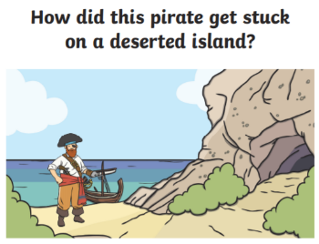  Write your own story and remember to use exciting adjectives and the correct punctuation. Ask someone to read it at home when you have finished. | Popping Punctuation: This sheet looks at the different types of punctuation used for different sentences. | Party Food Planning.  Tom and Sophie are having a birthday party. Imagine you are having a party. Write a list and describe all the food you would like. | Writing instructions.  Think about food you have prepared at home. For example flapjacks or a salad. Imagine you are writing instructions to an alien who has never been to Planet Earth and make sure that your instructions are really clear and in the correct order!  