Reading Tasks- Click the underlined
Choose a character from your current reading book. Ask someone at home to choose one, too. Pretend to be the characters. Ask each other questions about what happens to them.  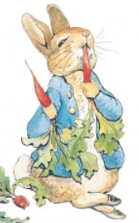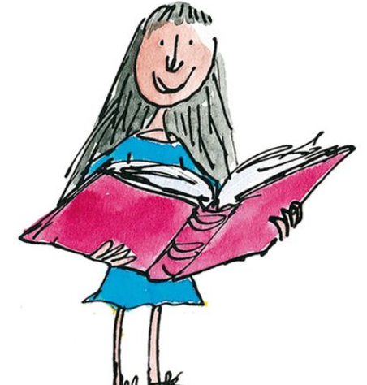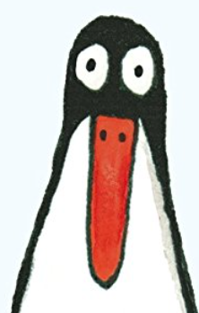 | Listen to this  Nonsense Poem by Spike Milligan  What do you like about the poem? What words stick in your mind? Have a go at performing it or writing your own nonsense poem and perform it to someone at home.  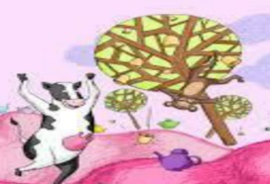 | 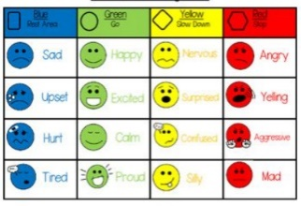  Choose a book that you have just read. Reflect on how you think the characters felt at different points of the story. Can you link this to the Zones of Regulation? Which zone do you think they were in and why? | The Lion and The Mouse  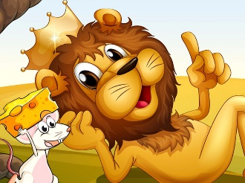  Watch this story. What do you think the message of this story is? Can you think of a time where it may have been relevant to your life? | The Sound Collector by Roger McGough  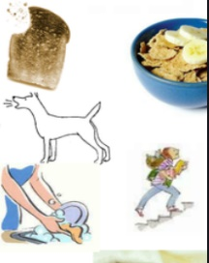  Listen to this poem and then see if you can act out the different everyday sounds that you come across in the poem e.g. scraping marmalade on toast.
Minibeasts reading comprehension  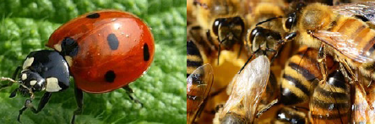 | Create a Comic Strip  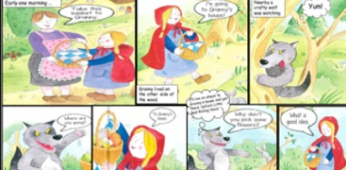  Think of a book that you have read recently. Can you create a comic strip all about it with characters and descriptions to ‘Wow’ the readers? | Layers of the Ocean reading comprehension  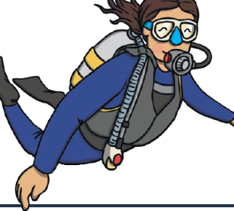 | Choose a book that you have already read and re-read it. Then, make a note of all of the interesting words that you come across and make a point of using them at some point at home today! | Build a Reading den at home. Get comfy and read your favourite / current book in your own space!  