Create your own code. Change each letter of the alphabet for a picture or symbol and write a secret, coded letter to a sibling/parent/carer. Can the recipient decode it? Can they make up their own code, too?  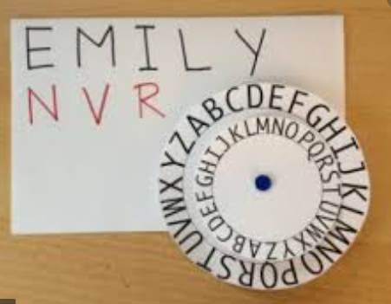 | 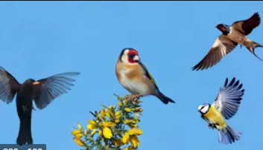  Keep a diary of the different birds you spot from your window or from the same spot outside your building over one week. You could draw the different birds and keep a tally of how many you spot each day. Make some notes about any interesting behaviour you observe. | Can you make your own zoo? Try using cardboard, paints, paper mache, glue, lollipop sticks, playdough, anything you like to build the zoo of your dreams. Label it clearly and be ready to present it to the class in a zoom chat. What animals do you have? what are their habitats like? Etc.  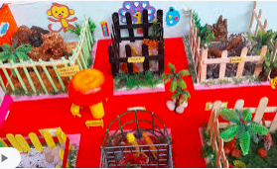 | Have a go at making your own Origami Butterfly. This is a really popular Japanese art which uses small bits of paper to make things!  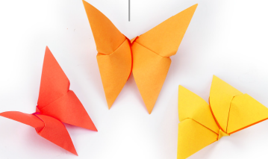 | 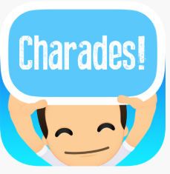  Find some time to play Charades with the people that you live with! Together, write a list of characters onto paper, fold them and put them into a pot. Taking turns, take one piece of paper out to reveal a character and then act out that character! Think about what they would say / do / behave like.
Marvellous Matrix

