Space Explorers
The emphasis this term is on creating a piece of home learning that shows your interest, engaging research and creativity!
You are asked to complete two projects of your choice. The first is due on Thursday 14th February. The second on Thursday 4th April.
 | Create a 3D model that represents our Solar System.  Think about how your model could differ from those simply representing the major planets! There are other features to our solar system that are of interest! You can use materials of your choice. | Create a 3D model of a real life ‘space ship’! This may resemble the Apollo Lunar Landing Module or the Sputnik Satellite or NASA’s Discovery or any spacecraft, artificial satellite, rocket or probe of your choice! | THE MILKY WAY is huge and wonderful!  Represent our Galaxy using whatever medium you feel! This can be a literal representation or can be very abstract, it could even be in music! Prepare to show your work and describe the ideas and intentions behind it!
 | We will be learning about famous astronauts and cosmonauts including Yuri Gagarin. Can you research an astronaut or cosmonaut of your choice and write about their life and achievements in a biography, poem or write about one of their major achievements in a diary entry form. | CREATE A SONG or POEM or RAP to represent the planets of the solar system so that we can remember their order and what their unique features are.  The order, in regards to distance from The Sun: Mercury, Venus, Earth, Mars, Jupiter, Saturn, Uranus, and Neptune. | Animals have been sents to Space including Laika. Do you think this has benefitted space exploration? Do you think that this is something that should be continued?  Animals should be sent into Space to benefit research and scientific discovery.  Write a debate FOR or AGAINST this motion.
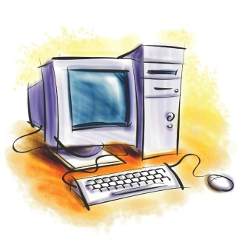 | Create a multiple choice quiz on the important milestones in space exploration that can be used to test your fellow classmates!  Make sure it is challenging, set them an interesting question followed by four potential answers, one of which should be correct! I will show you how to hyperlink and create buttons in class. | A timeline or presentation on the history of the INTERNATIONAL SPACE STATION!  Create a timeline of how the International Space Station was made, by whom and what it is used for! Include images to help explain how they survive in space for long periods of time. You can use | ANIMATE or DESIGN- what Mars could look like with human inhabitants in the next century. Using any method or program you’re comfortable with, create a small animation or digital image/plan that shows what Mars could look like in the future.
 | The mission to Mars goes wrong, you report the presence of an alien life form!  Write a short story about humans making contact with alien life, you can use whatever genre you like, even mix two genres! Think about the reader and what would make a memorable twist! | Write a SCIENCE-FICTION script that you and a group of actors could perform for the class.  This can be set in any sub-genre (i.e. you can have elements of love, horror, comedy or action) just remember it has to be entertaining! | We will be researching and creating timelines on the history of space exploration. Could you recreate that in comic form? You can include quotes and dates and add your own illustrations.

