Over this half-term complete 1 or 2 of these home learning activities. Think carefully about which ones you want to do, and create fantastic pieces of work to share with the rest of the class! Please bring your projects in on the 18th of October 2018 for a Show and Tell session on that day.
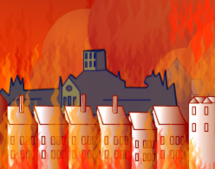 | Mapping London  After the Great Fire, King Charles II asked for a new map of London to be drawn. Draw a map of your neighbourhood or somewhere you know well. Remember to include important buildings and label them. | Be an artist!  Lots of people recorded the events of the fire in different ways. Many artists chose to show the view of the fire raging from across the River Thames. Create your own artwork using the London skyline or the Thames as inspiration. | Great Fire diary  Imagine you were alive at the time of the Great Fire of London. Write your own diary entry describing the events of the night when the fire started. You could write as Thomas Farrinor or or Samuel Pepys.
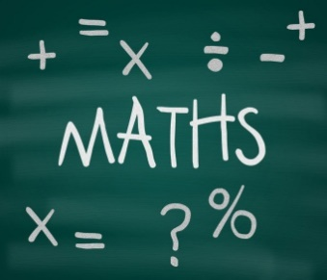 | Place Value investigator  Place Value Game  2 players. Write numbers on cards from 1-10. Place all cards face down. Both players take 2 cards each. Use your two cards to make the biggest 2 digit number that you can.  E.g. If you draw a 3 and a 7 you could either have 37 or 73 as your number.  The winner is whoever has the biggest number.  Try also with who can make the smallest number? Who can make a number closest to 50? Can you make your own rule also? | Code breaking  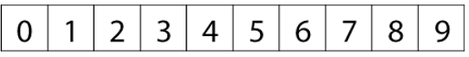  Can you arrange these digits in the five boxes below to make two-digit numbers as close to the targets as possible? You may use each digit once only.  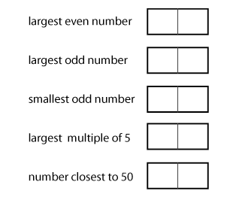 | Tug of war!  For this game, you will need to:  Make your own 0 – 20 or 0 - 30 number line. Find a counter or small object and a dice.  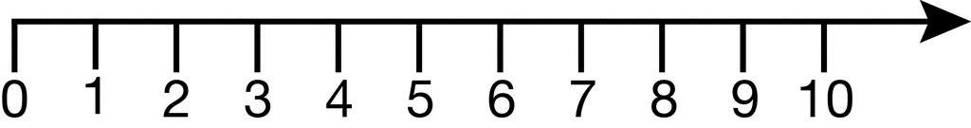  The rules: Player 1 is +, player 2 is -.  + moves forwards on the numberline, - moves backwards.  Player 1 rolls the dice. They get to move the counter that number of jumps forwards. Player 2 rolls the dice and moves the counter backwards that number of jumps.  The winner is the first to reach their end of the number line.
 | Lonely Beast mask  Design and create a Lonely Beast mask. You could make more masks for friends or family members and have your own party, like at the end of the story. | A guidebook for beasts  The Lonely Beast travelled all the way to the city to try to find other beasts. At first people were scared of him and ran away, but eventually he won them round. As the Beast, write a guide book for other beasts who may want to travel to the city. | Lonely Beast recipe cards  The Lonely Beast loves baking cakes. Do you know any delicious cake recipes? Make a recipe card or two for the beast, so he can try some delicious new treats.

